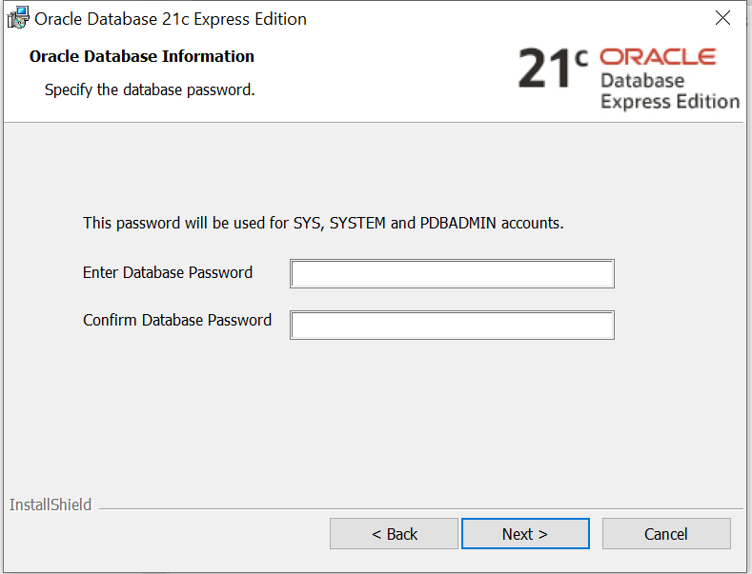
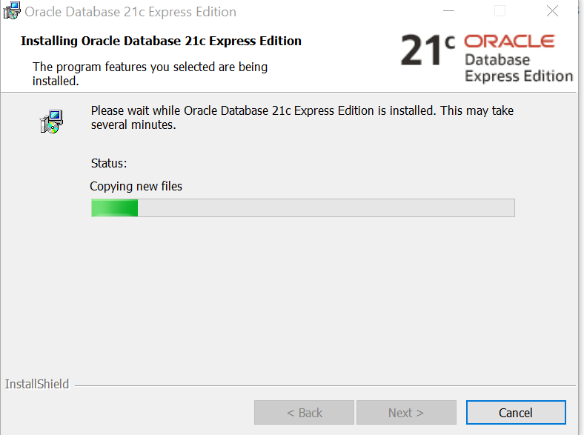

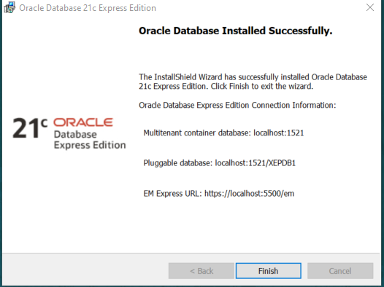
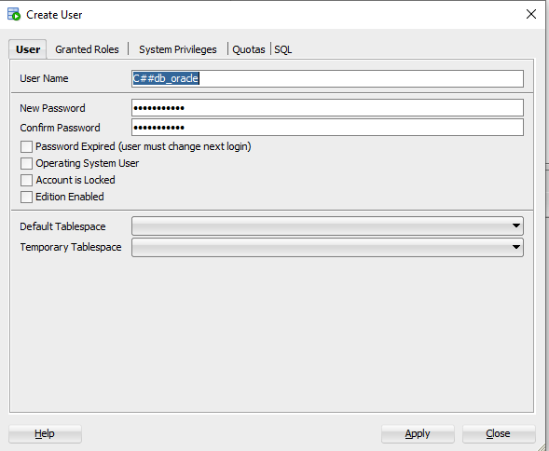
Or syntax CREATE USER "C##db_oracle" IDENTIFIED BY "password" ;

After instaling Oracle Database, we need SQL Developer

Download SQLDeveloper

Creare conectare SQL Developer
https://www.youtube.com/watch?v=58V-w3buWm4

Service name (?): xepdb1

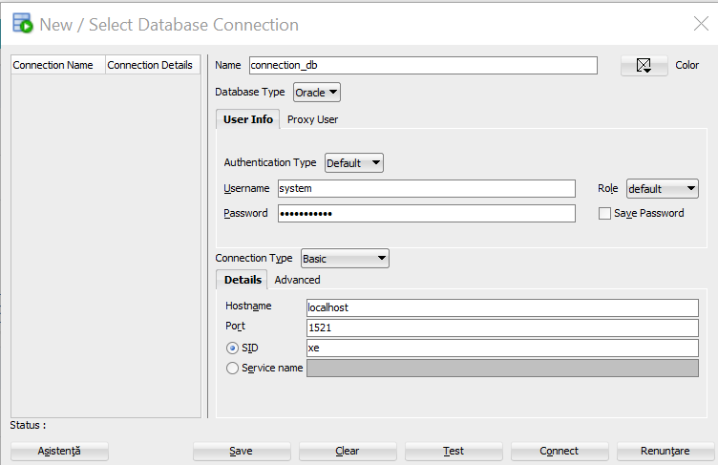
Create new user from Other Users
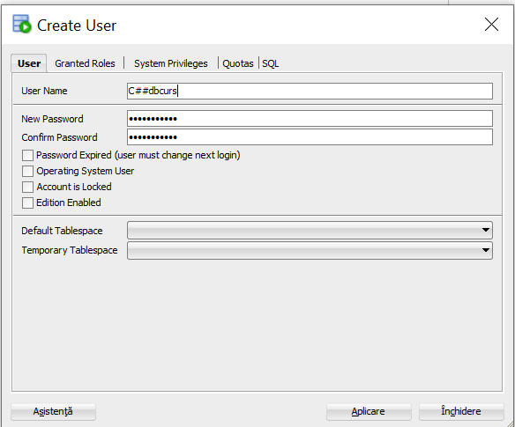

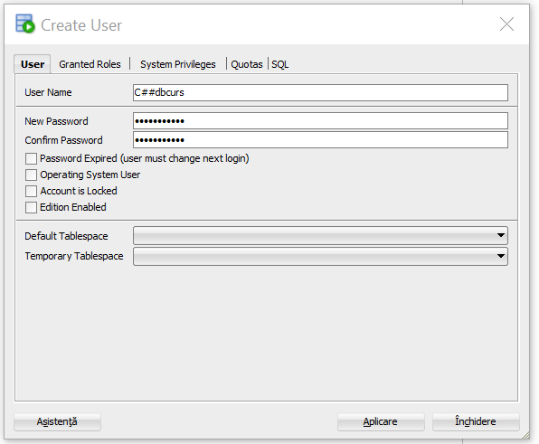

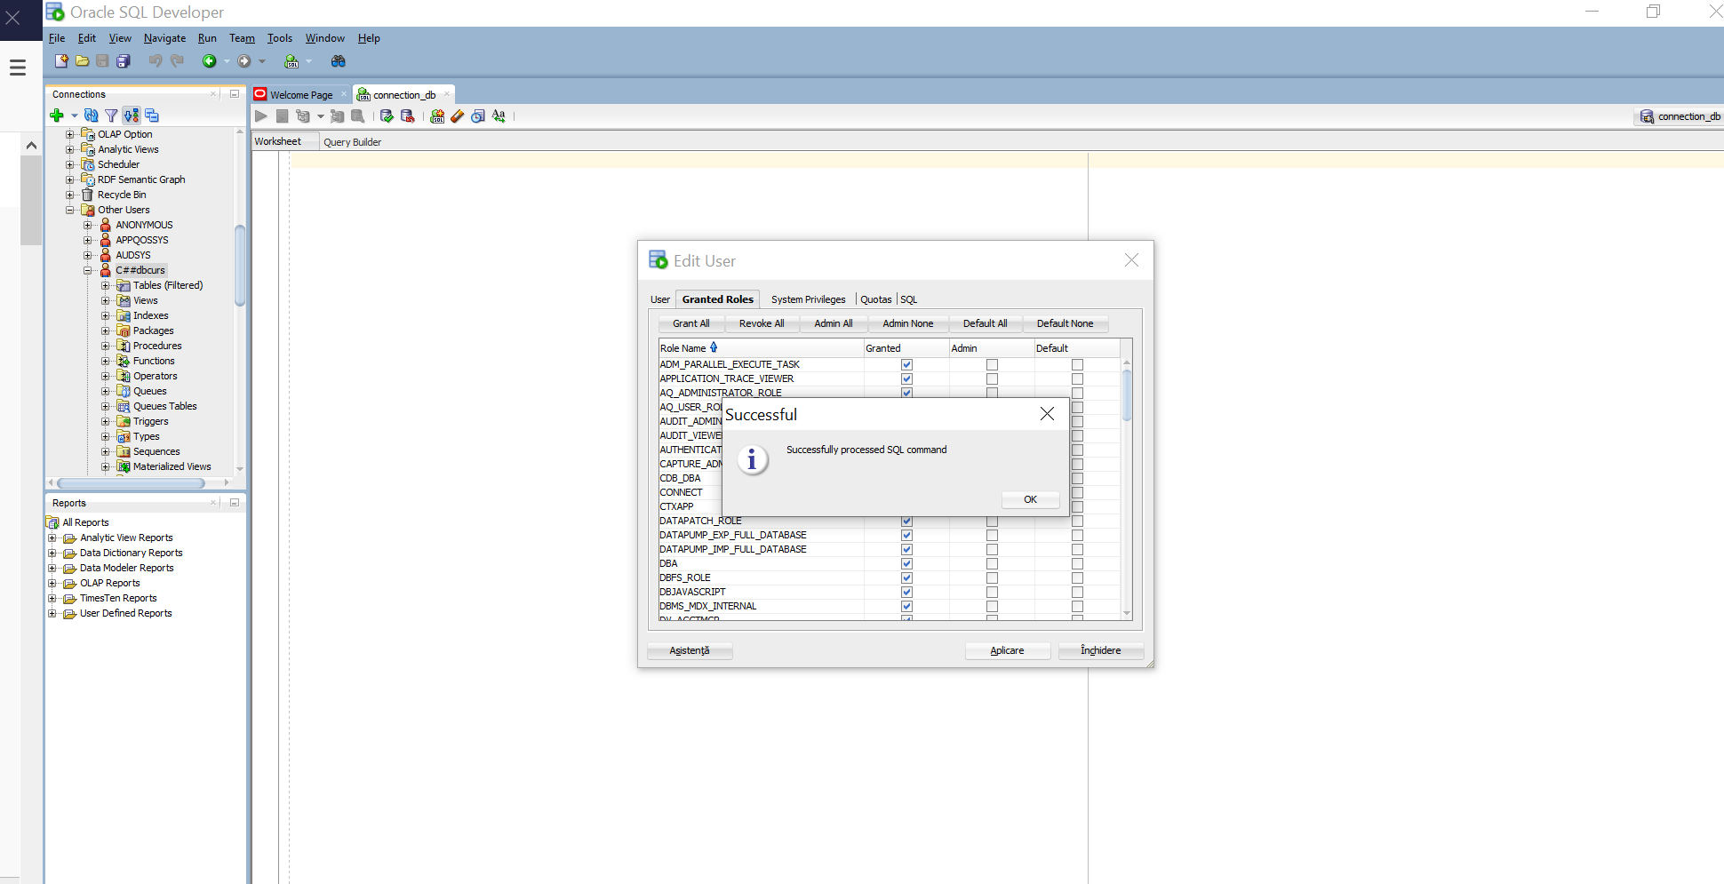

ALTER USER user_name IDENTIFIED BY new_password;

ALTER USER c##dbcurs IDENTIFIED BY "password";
To assign new privileges to an u.
grant all privileges to dac;

If you don’t install Oracle DB, you can use for now Live SQL https://livesql.oracle.com/apex/f?p=590:41:17475995580722:::41:P41_ID:148405776030629168359882238551164482016

